Oasis Home Venues
We want to welcome you to whichever sporting event you are attending. Please note that most of our events have entrance fee and we accept GoFan www.gofan.co for online payments.
Here are the addresses to our athletic venues as we have limited facilities at our school and use many of the beautiful facilities provided by the City of Cape Coral.
Fall Home Contest Venues
Football
Our home games are played at Caloosa Middle School
610 Del Prado Blvd S, Cape Coral, FL 33990
https://goo.gl/maps/kvocvMnJxAtJy7kp6
Concessions and rest room facilities are available. Please park on the north side of the school. Dressing facilities for our visiting teams are limited.
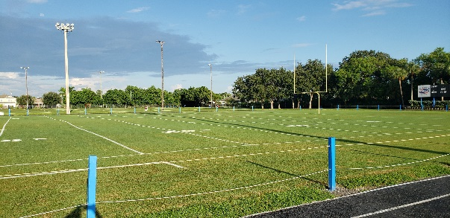
Volleyball
Our home games are played at “The Shark Tank” on our schools’ campus.
3519 Oasis Blvd, Cape Coral, FL 33914
https://goo.gl/maps/CmLmAkX28pfGwVTV7
Concessions and rest room facilities are available. Please park behind the school in any available spots at our school.
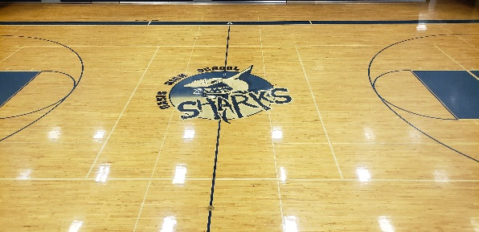

Cross Country
Our home races are run on the grounds of our school’s campus and the surrounding neighborhood.
3519 Oasis Blvd, Cape Coral, FL 33914
https://goo.gl/maps/CmLmAkX28pfGwVTV7
Concessions and rest room facilities are available. Please park behind in any available spots at our school.

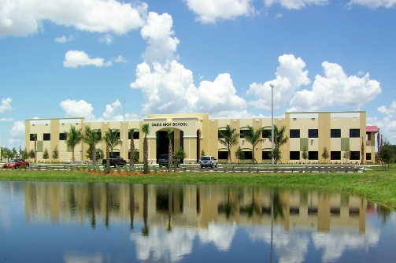

Swimming
Our home meets are swum at Cape Coral High School
2300 Santa Barbara Blvd, Cape Coral, FL 33991
https://goo.gl/maps/9txYnijKTLSYqsq97
Rest room facilities are available. Please park in the school parking lot. Dressing facilities for our visiting teams are limited.

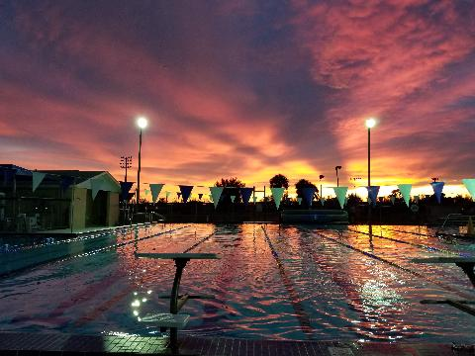

Golf
Our home matches are played at Royal Cape Golf Club
11460 Royal Tee Cir, Cape Coral, FL 33991
https://goo.gl/maps/xoJjBnufxgxUKChK8
Restaurant, changing areas and rest room facilities are available. Parking at the course.
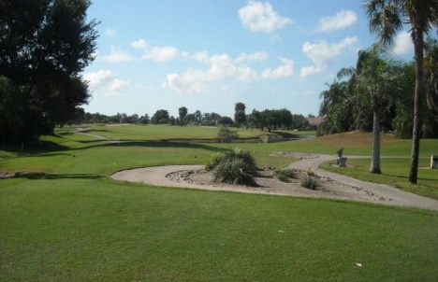

Contact Information
AD Michael O’Brien
239-541-1167 x7451

Oasis Home Venues
We want to welcome you to whichever sporting event you are attending. Please note that most of our events have entrance fee and we accept GoFan www.gofan.co for online payments.
Here are the addresses to our athletic venues as we have limited facilities at our school and use many of the beautiful facilities provided by the City of Cape Coral.
Winter Home Contest Venues
Basketball & Wrestling
Our home games are played at “The Shark Tank” on our schools’ campus.
3519 Oasis Blvd, Cape Coral, FL 33914
https://goo.gl/maps/CmLmAkX28pfGwVTV7
Concessions and rest room facilities are available. Please park behind the school in any available spots at our school.
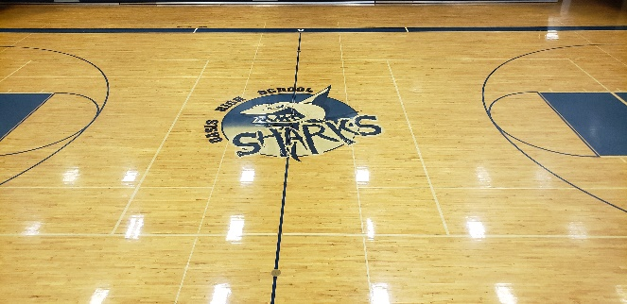

Soccer
Our home games are played at the Pelican Soccer Complex
4020 SW 2nd Ct, Cape Coral, FL 33914
https://goo.gl/maps/3gtxvkHuZoxTbh6b9
Rest room facilities are available. Please park in the parks parking lot. Dressing facilities for our visiting teams are limited.
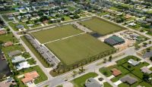
Oasis Home Venues
We want to welcome you to whichever sporting event you are attending. Please note that most of our events have entrance fee and we accept GoFan www.gofan.co for online payments.
Here are the addresses to our athletic venues as we have limited facilities at our school and use many of the beautiful facilities provided by the City of Cape Coral.
Spring Home Contest Venues
Softball and Baseball
Our home games are played at Cape Coral Sports Complex
1410 Sports Blvd, Cape Coral, FL 33991
https://goo.gl/maps/V6k9SJdp2ZKqowb29
Rest room facilities are available. Please park in the parks parking lot. Dressing facilities for our visiting teams are limited.
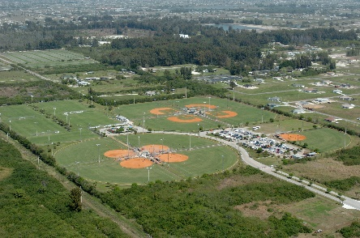

Tennis
Our home games are played at Mariner High school
701 Chiquita Blvd N, Cape Coral, FL 33993
https://goo.gl/maps/RgzLhLD9gcXq1fQv7
Rest room facilities are available. Please park in the parks parking lot. Dressing facilities for our visiting teams are limited.
